REF : NB10260217/16/09/2014

Training title: Satellite Image Processing: Operational Processor Adaptation.
Field: Development and Studies
Speciality: Image processing

Subject
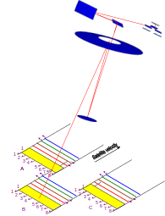

Image production subsystems require light and fast image processing modules. The Space System business line of Airbus Defence & Space has developed a family of image processing modules for radiometric and geometric corrections.

The objective of the training period is to adapt an existing operational image processing component to different contexts (SPOT 6/7 for example), and to add new processing modules.
L1 processing
This activity will cover:
- Adaptation of existing software: this activity will cover needs analysis, specification of needed methods, implementation and validation. In the frame of those evolutions a generic approach should be proposed in order to make the software as adaptable as possible.
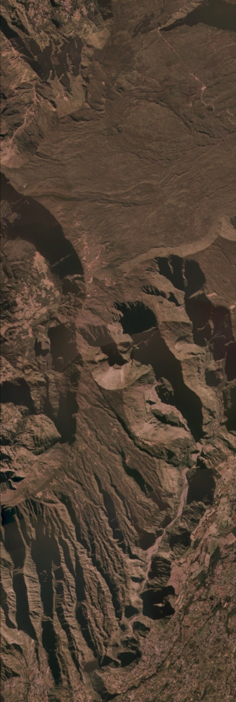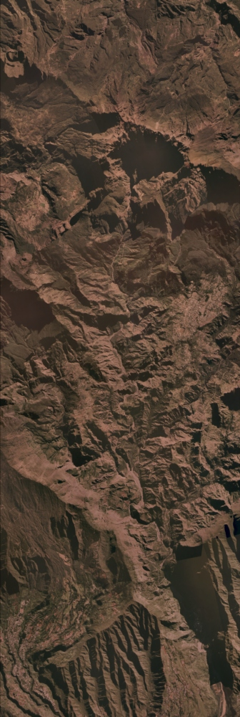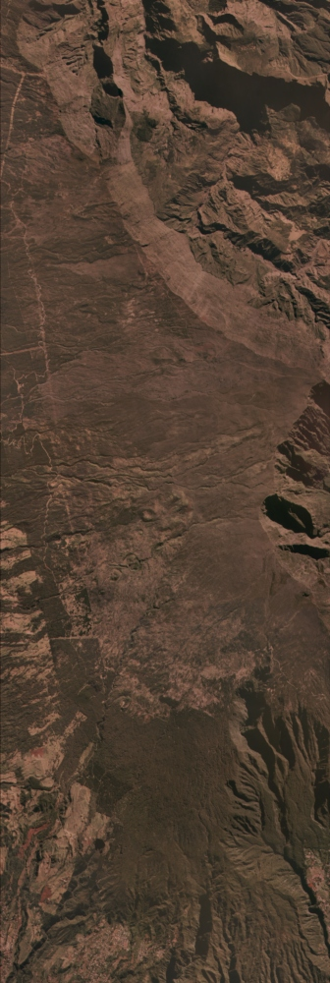
- Development of image processing module: this activity consists in developing some specific image processing algorithms needed for future projects. Prototyping of the algorithms under Astrium image engineering environment will be done as well as operational development and integration to the adapted processing module.
L2 processing
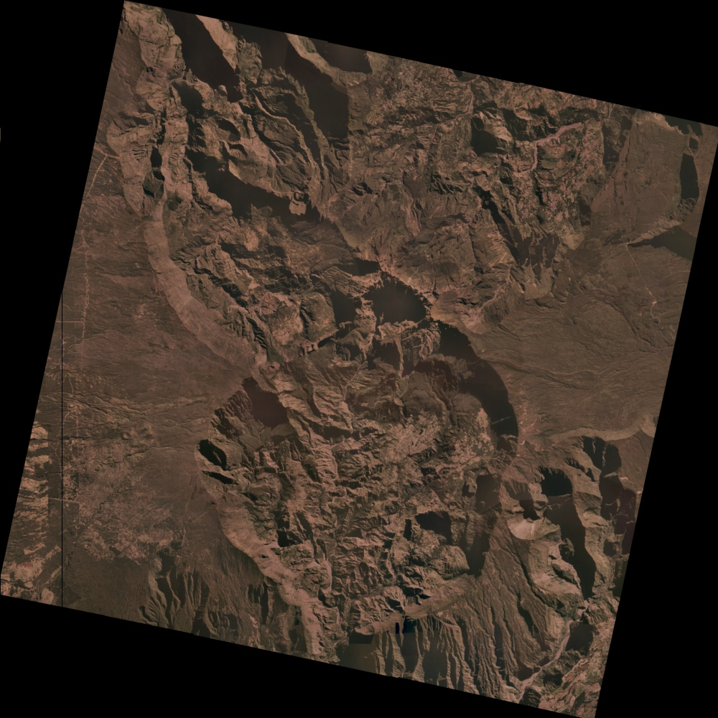

Operational image processing software will be developed in C++ language; prototyping will be performed in Matlab under in house image processing framework (SIMAGE).

A particular emphasis shall be put on code implementation optimisation and reusability.

Company background
The Space System business line of Airbus Defence & Space is the European leader in the field of optical Earth Observation systems. The company, through is history, is a pioneer of space industry, responsible for the development of the first Earth Observation space systems in Europe, starting with the SPOT family. Since this time, the company has led the major European developments in the fields, through programs such as METOP, ERS, ENVISAT, HELIOS, PLEIADES or SPOT6. This experience developed is now applied on export turn-key programs such as FORMOSAT, THEOS, ALSAT, CHILI or KazEOSat-1, involving up to sub metric resolution systems, or such as COMS, a geostationary meteorological satellite for Korea.
This evolution conveyed Airbus Defence & Space to develop a strong expertise in Image Quality, Image Processing and Image Simulation through a group of about 50 engineers in 2014, constituting the Image Chain department (TSOEF52). The Image team carries out activities in fundamental image domains such as Image simulation, Ground processing, Image quality, In-orbit testing, Embedded processing, Vision based navigation and Dedicated R&D activities.

Required knowledge
- Generic knowledge in signal and image processing as well as numerical analysis,
- Matlab, C++.

Desired education
- Engineering school or Master, with specialisation in signal and image processing, or applied mathematics and software development

Training period length: 5 to 9 months between January and September 2015.

Location Airbus Defence & Space – Space Systems
31 rue des cosmonautes 31402 Toulouse Cedex 4, France
Unit TSOEF52 – Image Chain department
Contact David Villa Pascual: David.VILLAPASCUAL@astrium.eads.net

