REF : NB10260216/16/09/14
Training title: Satellite image processing
Field: Operations and R&D
Speciality: Image processing

Subject
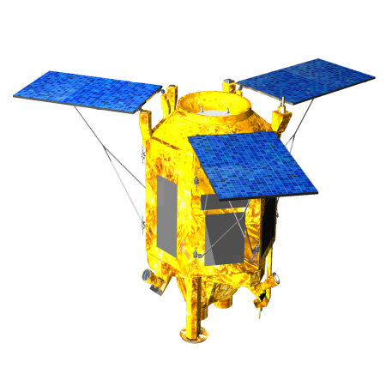
Image processing is one of the key components of the acquisition chain for observation missions and planetary exploration missions. Needs in processing are of various types: restoration, registration, image fusion, tracking, navigation, image simulation…

The training period will consist in developing and testing new algorithms in one of the above-cited domain within the Space System business line of Airbus Defence & Space. The subject will be more precisely detailed at the beginning of 2015, depending first, on the current projects and studies of the image section and second, on the aspirations of the candidate.

The subjects already identified this year are the following:
- Monitoring of SPOT6/7 satellite image quality
- Improvement of cloud detection algorithm
- Video processing
- 3D reconstruction
- Image based navigation (for planetary exploration or for UAVs)

Depending on the planning of the internship, the contents may be adapted to be as interesting as possible.

The trainee shall have both a solid image processing background and computer programming skills (Matlab and/or C/C++).

Company background
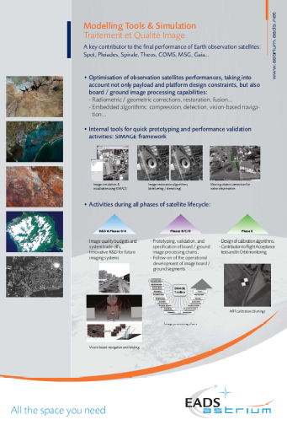
The Space System business line of Airbus Defence & Space is the European leader in the field of optical Earth Observation systems. The company, through is history, is a pioneer of space industry, responsible for the development of the first Earth Observation space systems in Europe, starting with the SPOT family. Since this time, the company has led the major European developments in the fields, through programs such as METOP, ERS, ENVISAT, HELIOS, PLEIADES or SPOT6. This experience developed is now applied on export turn-key programs such as FORMOSAT, THEOS, ALSAT, CHILI or KazEOSat-1, involving up to sub metric resolution systems, or such as COMS, a geostationary meteorological satellite for Korea.
This evolution conveyed Airbus Defence & Space to develop a strong expertise in Image Quality, Image Processing and Image Simulation through a group of about 50 engineers in 2014, constituting the Image Chain department (TSOEF52). The Image team carries out activities in fundamental image domains such as Image simulation, Ground processing, Image quality, In-orbit testing, Embedded processing, Vision based navigation and Dedicated R&D activities.

Required knowledge
- Generic knowledge in image processing as well as numerical analysis,
- Matlab or C/C++ ; Windows & Linux OS

Desired education
- Engineering school or Master, with specialisation in signal and image processing, or applied mathematics.

Training period length: 5 to 9 months between January and September 2015.
+ Possibility of a one year internship.

Location Airbus Defence & Space – Space Systems
31 rue des cosmonautes 31402 Toulouse Cedex 4, France
Unit TSOEF52 – Image Chain department
Contact David Villa Pascual: David.VILLAPASCUAL@astrium.eads.net

