Jean-Philippe Bernard

Centre d’Etudes Spatiales du Rayonnement
9 Av du colonel Roche
BP 4346-Cedex 4
31028 Toulouse
France
Jean-Philippe.Bernard@cesr.fr
http://www.cesr.fr/~bernard
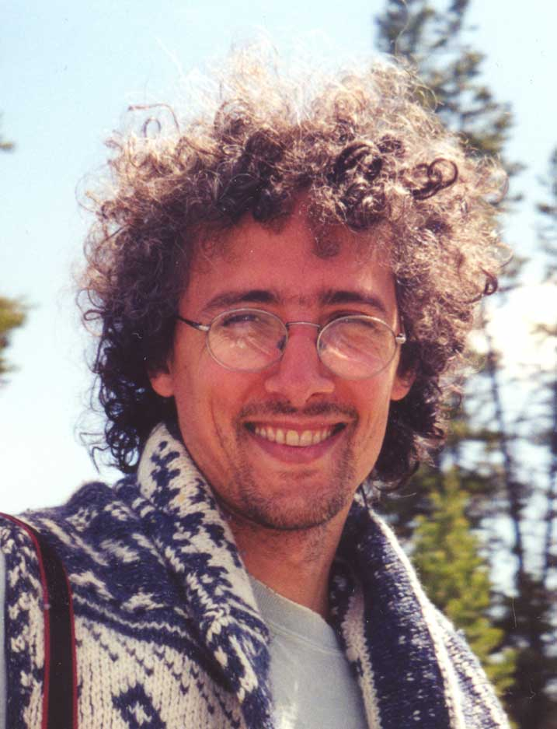

Education
1991 Ph.D. Astrophysics, University Paris VII

Positions
1992-1993 Post-Doc, Nagoya University, Nagoya, Japan.
1993-1995 Post-Doc, Infrared Processing and Analysis Center, Pasadena, CA, USA
1996-present Chargé de recherches at CNRS

Professional experience
1991-present Study of the interstellar matter from diffuse cirruses to molecular clouds
Observational cosmology in the domain of X-rays and CMB
1991-present ~ 50 refereed publications on interstellar matter and observational cosmology.
2001-present Scientific associate on the Herschel Project
2001-present PI of the PILOT balloon-borne experiment
2000-present Coordinator of 3 sub working groups of the Planck project
2000-present Coordinator of the “systematic effect detection” activities of the Planck/HFI DPC
1999-present Scientific associate on the Planck project
1999-present Co-I of the Archeops balloon-borne experiment
1991-1999 Co-I of the Pronaos balloon-borne experiment
1998 Co-I of an accepted Associate Investigator Program on the WIRE satellite
1998-2000 Calibration scientist of the XMM-EPIC instrument
1996-2000 Data Analysis of the ISO mission

Overall scientific interest
Observational cosmology in the field of X-ray astronomy (Galaxy clusters morphology and luminosity function) and millimeter astronomy (Cosmic Microwave Background, Sunyaev-Zel’dovich effect on galaxy clusters).
Study of the interstellar matter from diffuse cirrus to dense molecular clouds through dust continuum and molecular emission using satellite and ground-based observations. Numerical modeling of the dust emission and radiative transfer in dust clouds. Study of the large-scale star formation in giant molecular clouds. Study of cold dust emission in the sub-millimeter. Application to foreground removal techniques for CMB experiments. Preparation of CMB polarization experiments, in particular with respect to identification and removal of foreground components.

Publications
http://www.cesr.fr/~bernard/JPB/Biblio/jpb_biblio.html

